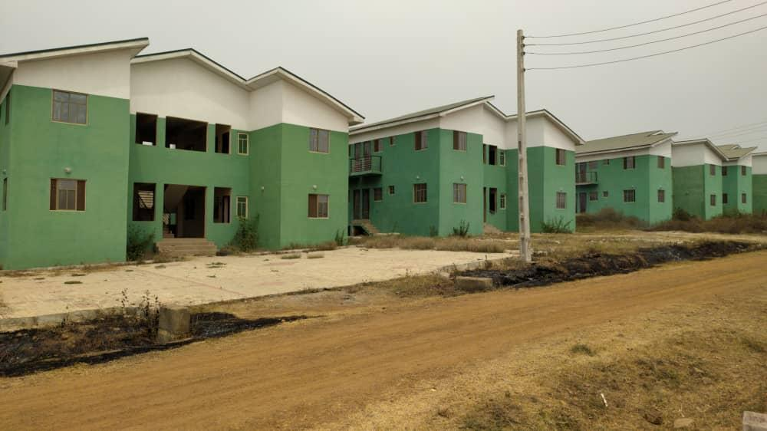

**OLUFEMI ADESOPE & CO**

**(Estate Surveyors & Valuers)**



```````` {! render = true}

VALUATION OF THE INTEREST IN LANDED PROPERTY LOCATED IN PACESETTER GARDENS ESTATE, ADEGBAYI AREA, Off IBADAN-IFE EXPRESSWAY AJODA IN EGBEDA LOCAL GOVERNMENT AREA OF OYO STATE

**Dated {month} {day} {year}**

**VALUATION CERTIFICATE NO:**

**VL/CMB/IBAD/{year}/02/OA&CO/00000{serialNo}**

**ON THE LANDED PROPERTY:**

Located In Pacesetter Gardens Estate, Adegbayi Area, Off Ibadan-Ife Expressway Ajoda In Egbeda Local Government Area Of Oyo State.

**SUMMARY OF VALUE:**

|  |  |
| --- | --- |
| **OPEN MARKET VALUE (~~N~~)** | |
| BUILDING | ~~N~~6,100,000.00 |
| **TOTAL** | ~~N~~6,100,000.00 |

|  |
| --- |
| **Total Open Market Value: Six Million, One Hundred Thousand Naira Only.** |

{IMAGE esvStamp}

**Valuation requested by:** {fullName}

**Valuer’s Name:** Olufemi Adesope & Co

**Valuer’s Category:**  External Valuers

**Valuer’s Registration No:** A-2792

**Date of valuation:** {day}{ordinalDay} {month}, {year}

{IMAGE dateImg}

{IMAGE smSignature}

{day}{ordinalDay} {month}, {year}

**VL/CMB/IBAD/{year}/02/OA&CO/00000{serialNo}**

{fullName},

{customerAddress}

Dear {salutation},

**VALUATION REPORT OF THE INTEREST IN THE LANDED PROPERTY LOCATED IN PACESETTER GARDENS ESTATE, ADEGBAYI AREA, Off IBADAN-IFE EXPRESSWAY AJODA IN EGBEDA LOCAL GOVERNMENT AREA OF OYO STATE:**

We refer to your instruction to carry out the valuation of the interest in the landed property located at Pacesetter Gardens Estate, Adegbayi Area, Off Ibadan-Ife Expressway Ajoda, in Egbeda Local Government Area of Oyo State and wish to state that we have conducted the inspection of same and are pleased to report as follows:

**PURPOSE OF VALUATION:**

The valuation certificate was requested to ascertain the Open Market Value of the property.

**BASIS OF VALUATION**:

In line with the purpose of valuation, the property has been valued on Market Value Basis.

By Market Value, we mean the estimated amount in Naira for which an asset or liability should be exchanged on the valuation date between a willing buyer and a willing seller in an arm’s length transaction after proper marketing and where the parties had each acted knowledgeably, prudently and without compulsion.

**METHODS OF VALUATION:**

In carrying out this exercise, we have adopted the following methods:

**For the Land: Market Approach:**

This involves comparing the subject property with identical or similar properties for which evidence of recent transaction is available or alternatively identical or similar properties that are available in the market for sale, making adequate adjustment on price information to reflect any differences between the subject property and the comparables in terms of actual time of transaction including the legal, physical, and economic characteristic of the properties.

**For the Buildings, Fence wall and Gates: Depreciated Replacement Cost Approach:**

This provides an indication of value using the economic principle that a buyer will pay no more for an asset than what it will cost him/her to own an equivalent asset of equal utility, whether by purchase or by construction.

Thus, the total construction cost of a new one is achieved through the application of the current construction rate to the measured building including other associated costs both of which have been depreciated to reflect its present physical condition, functional and economic obsolescence to arrive at a fair price for its replacement.

**DESCRIPTION & ADDRESS OF PROPERTY:**

The subject property is a 1 bedroom 8 in 1 flat, which has a foot print of approximately 40.0 square meters being House {houseNumber} located at Pacesetter Gardens Estate, Adegbayi Area, off Ibadan-Ife Expressway Ajoda in Egbeda Local Government Area of Oyo State.

**TENURE/TITLE TO THE PROPERTY:**

The title to the property is evidenced by a Deed of Mortgage from Coop Property Development Limited in favour of {fullName}. We presume that the title is good and free from any encumbrance except those limitations imposed by the Land Use Act No. 6 of 1978.

**CONSTRUCTION DETAILS:**



Construction is with sandcrete blockwall, rendered smooth and painted.

Roof comprises a framework of wooden trusses clad with corrugated aluminium roofing sheets ceiled underneath with p.v.c and asbestos.

Doors are wooden panelled types while windows are of fabricated aluminium sliding types all fitted with iron burglar proofs. Flooring is finished variously with ceramic tiles.

**GENERAL ASSUMPTIONS IN ARRIVING AT OPINION OF VALUE:**

In determining the value of the property, we have assumed;

1. That information supplied to us is correct.
2. That the title to the property is good and marketable.
3. That the property is free from all onerous restrictions, encumbrances or charges.
4. That the property is not adversely affected by, or subject to compulsory acquisition, road widening, new road proposal or planning regulations and environmental laws as are applicable as at the date of valuation.
5. That there are no hidden or unapparent conditions of the property, subsoil, or structure that rendered it more or less valuable.
6. No responsibility is assumed for such conditions or for arranging for engineering studies that may be required to discover them.

**CONDITION:**

Our inspection was limited to physical observation of the property. We have not carried out any soil test or other sub structural investigations and our valuation has been prepared based on the conditions and provisions indicated above.

**DATE OF PHYSICAL INSPECTION:** {day}{ordinalDay} {month}, {year}

**VALUATION:**

**WE ARE OF THE OPINION** that the **OPEN MARKET VALUE** of the interest in the landed property located at Pacesetter Gardens Estate, Adegbayi Area, off Ibadan-Ife Expressway Ajoda in Egbeda Local Government Area of Oyo State, herein described was as at {day}{ordinalDay} {month}, {year} in the sum indicated in the following schedule:

|  |  |
| --- | --- |
| **OPEN MARKET VALUE (~~N~~)** | |
| BUILDING | 6,100,000.00 |
| **TOTAL** | ~~N~~6,100,000.00 |

|  |
| --- |
| **Total Open Market Value: Six Million, One Hundred Thousand Naira Only.** |
|  |

**WARRANTIES, EXCLUSIONS, DISCLOSURES AND CERTIFICATION:**

This report is confidential to the specific purpose for which it refers and therefore no responsibility is accepted from any third party in respect of its contents. If however, our opinion of value of the subject property or the general advice as given and as expressed in the report are to be disclosed to a third party; the general assumptions for deriving the value as stated in the full report should be stated.

We certify to the best our knowledge and belief that:

1. The statements of fact contained in this report are true and correct.
2. This report is prepared without any expectation of fee compensation.
3. The report is unbiased as the analysis of data and opinions expressed in it have been undertaken with the adoption of appropriate professional ethics and guidelines.

{IMAGE stamp}

{IMAGE signature}

**For: OLUFEMI ADESOPE & CO**

**FRC/2014/NIESV/00000007210**

**SIGNED AND SEALED**